**SOLSQUARE USER GUIDE**

SolSquare supports all popular wallets, Phantom, Solflare, and Backpack.

User Steps to use SolSquare (using Phantom wallet as an example) in Beta Test

1. Download Phantom Wallet extension

2. Configure Phantom Wallet to use in TestNet mode

Click this

Go to settings (by clicking the icon at the bottom )

Go to Developer settings

And select testnet mode

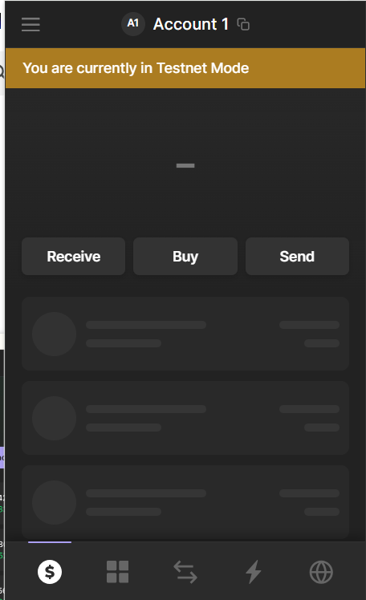

3. Send some testnet SOL to your wallet by :

4. Open https://www.solsquare.net/

5. Connect to the phantom wallet

6. You should see the following page.

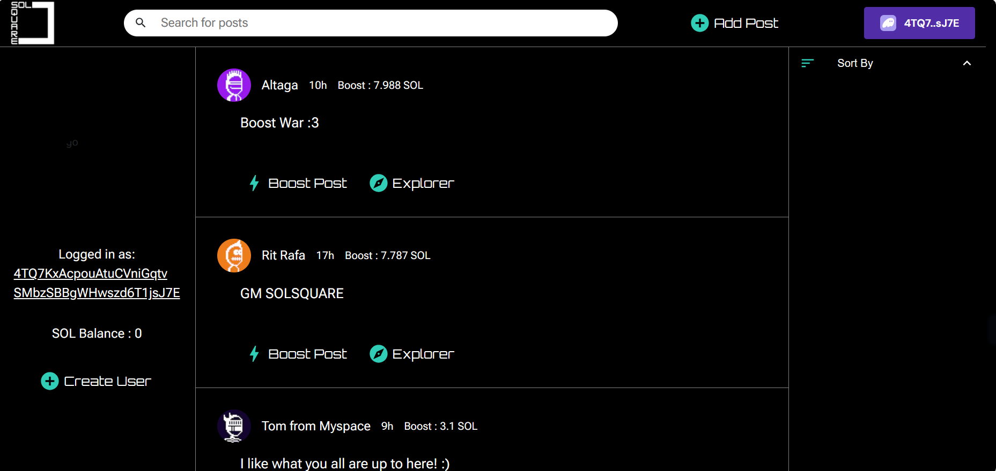



7. Add your post, and confirm your transaction in the Phantom Wallet

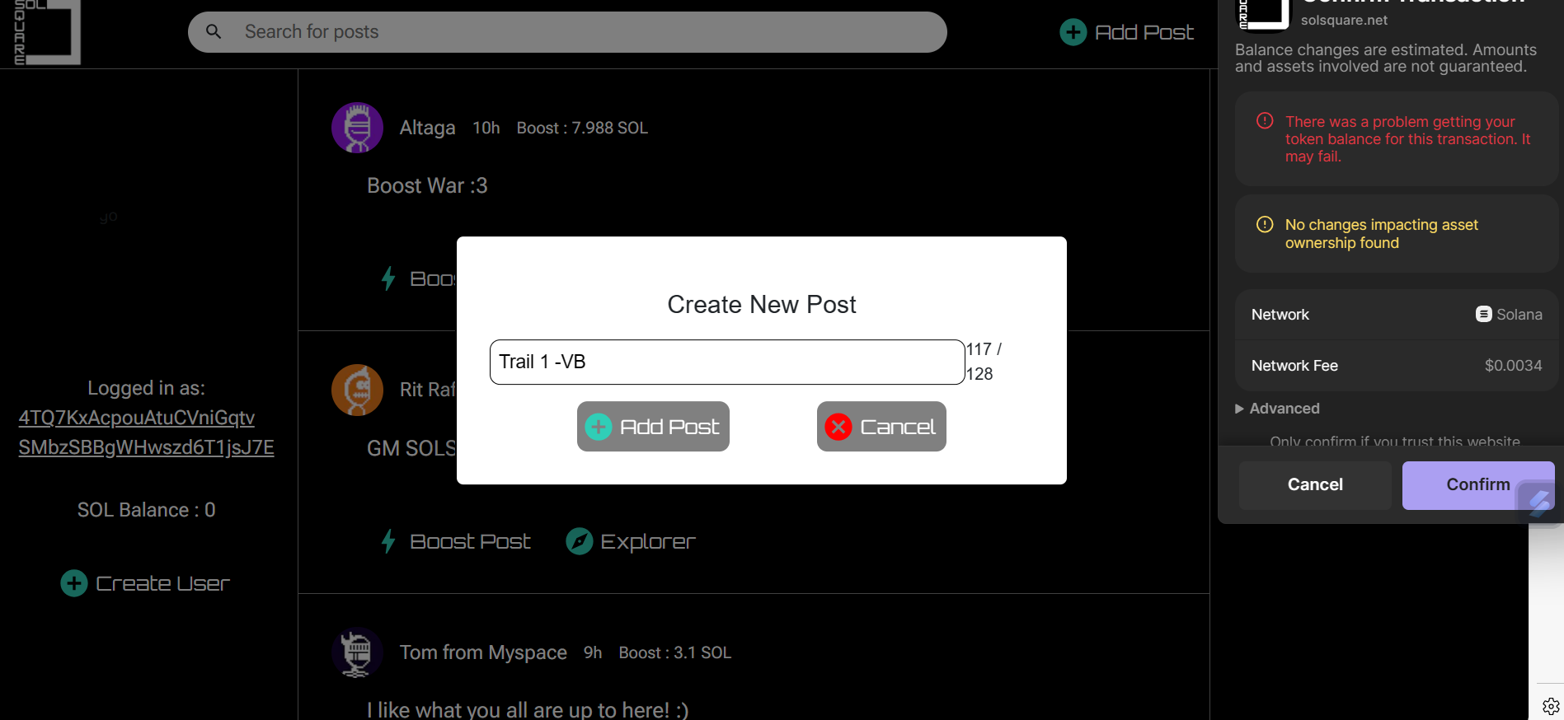



8. You can Boost a post in Public, Customize the amount to Boost a post.

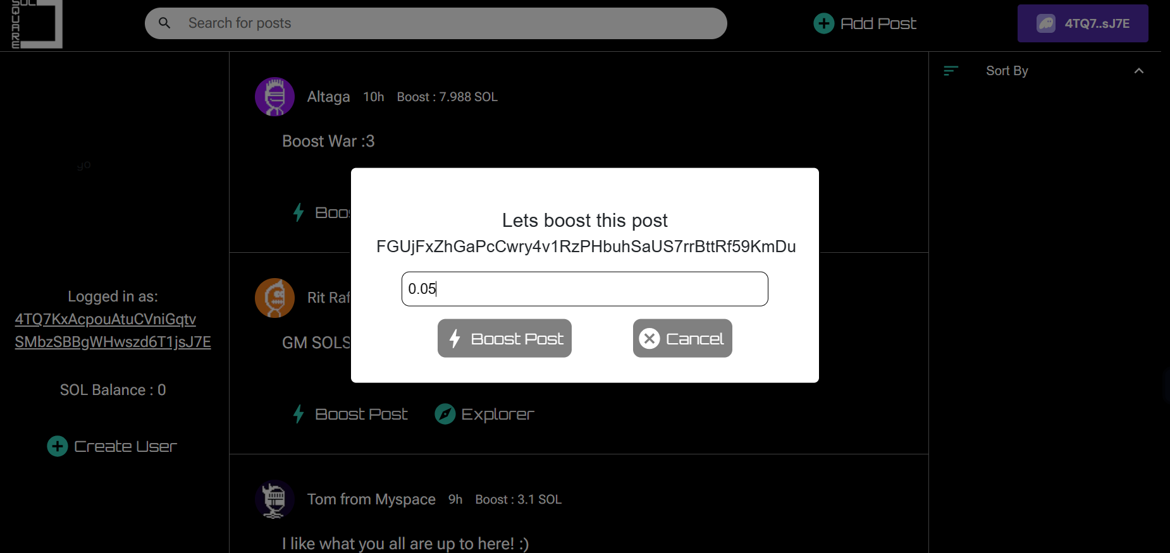



9. Create a user name:

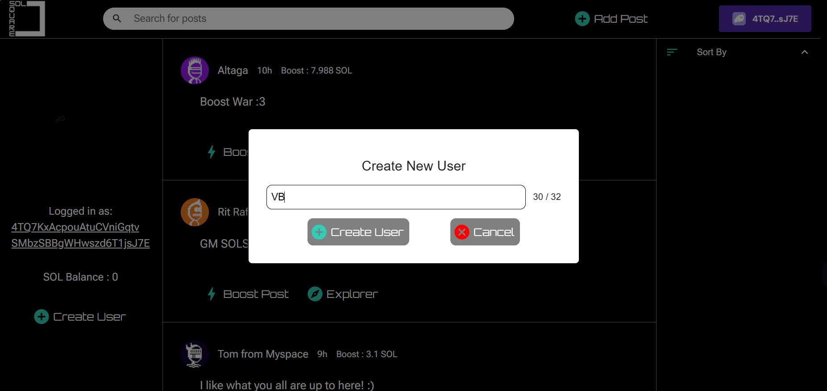



10. You can sort By the date of the tweet (OR) By the Boost

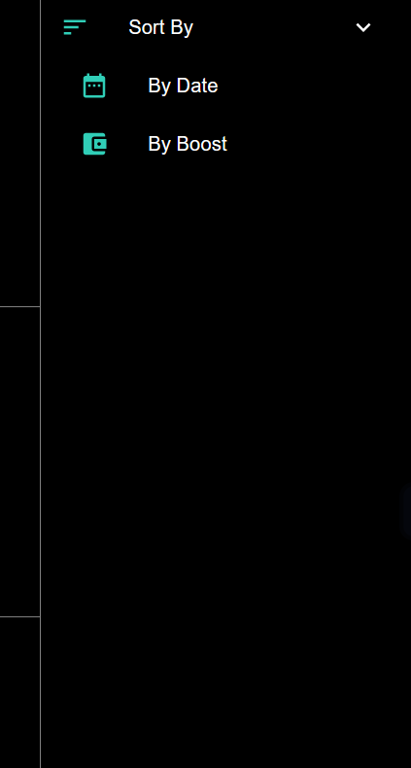

11. Happy Tweeting.

12. Please provide feedback @